HackerRank - FizzBuzz
Code:
#include <stdio.h>

int main() {
for (int i = 1; i <= 100; i++) {
if (i % 3 == 0 && i % 5 == 0) {
printf("FizzBuzz\n");
} else if (i % 3 == 0) {
printf("Fizz\n");
} else if (i % 5 == 0) {
printf("Buzz\n");
} else {
printf("%d\n", i);
}
}
return 0;
}

Screenshot:

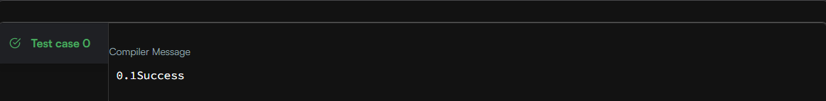

Link:
https://www.hackerrank.com/challenges/fizzbuzz/problem

